1. Basic algorithmic thinking in R

1.1 Lowest temperature manual calulation

Screenshot of created function for lowest temperature

Print function that prints the result of the function.



Screenshot of created function for highest temperature

Screenshot of created function for average temperature

#step2

#Enter the name of 10 cities and their temperature for each day in 1 month

#The print the min, max and average temperature using borh own functions an

#built in functions

for(i in 1:10){

city <- (c(readline(prompt = "Enter cityname: ")))

temp <- tempInCity()

cat("Own function lowest temperature in", city ,"is", lowestTemperature(temp), "degrees\n")

cat("Built in lowest temperature in", city ,"is", min(temp),"degreees\n")

cat("Own function highest temperature in", city ,"is", highestTemperature(temp), "degrees\n")

cat("Built in highest temperature in", city ,"is", max(temp),"degreees\n")

cat("Own function average temperature in", city ,"is", averageTemperature(temp), "degrees\n")

cat("Built in average temperature in", city ,"is", mean(temp),"degreees\n")

}

1. This dataset is about chronic Kidney Disease in India and contain around 25 columns of data, data such as red blood cell count, whte blood cell count Some missing values saying NA that I have replaced with mean values for that particular column. Also some with empty fields that I first had to replace with na before I could calculate mean on those columns too and replace the na’s with mean values.

Another way to do it would be to delete all rows where there is NA or empty values but that would leave the dataset with only 158 out of 400 rows left. Here we see a couple of NA values

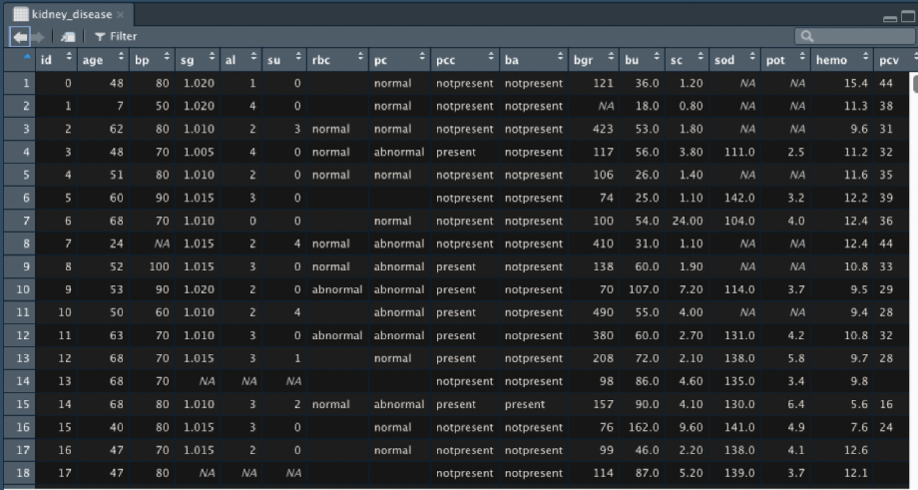  
And by running this script

#Step 1 - Replace empty values with NA

kidney_disease[kidney_disease==""] <- NA

#Step 2 - Replace missing numerical values with mean value from the same column.

meanAge <- mean(kidney_disease$age, na.rm = TRUE)

kidney_disease$age[is.na(kidney_disease$age)]<-meanAge

meanBP <- mean(kidney_disease$bp, na.rm = TRUE)

kidney_disease$bp[is.na(kidney_disease$bp)]<-meanBP

meanSG <- mean(kidney_disease$sg, na.rm = TRUE)

kidney_disease$sg[is.na(kidney_disease$sg)]<-meanSG

meanAL <- mean(kidney_disease$al, na.rm = TRUE)

kidney_disease$al[is.na(kidney_disease$al)]<-meanAL

meanSU <- mean(kidney_disease$su, na.rm = TRUE)

kidney_disease$su[is.na(kidney_disease$su)]<-meanSU

meanBGR <- mean(kidney_disease$bgr, na.rm = TRUE)

kidney_disease$bgr[is.na(kidney_disease$bgr)]<-meanBGR

meanBU <- mean(kidney_disease$bu, na.rm = TRUE)

kidney_disease$bu[is.na(kidney_disease$bu)]<-meanBU

meanSC <- mean(kidney_disease$sc, na.rm = TRUE)

kidney_disease$sc[is.na(kidney_disease$sc)]<-meanSC

meanSOD <- mean(kidney_disease$sod, na.rm = TRUE)

kidney_disease$sod[is.na(kidney_disease$sod)]<-meanSOD

meanPOT <- mean(kidney_disease$pot, na.rm = TRUE)

kidney_disease$pot[is.na(kidney_disease$pot)]<-meanPOT

meanHemo <- mean(kidney_disease$hemo, na.rm = TRUE)

kidney_disease$hemo[is.na(kidney_disease$hemo)]<-meanHemo

meanPCV <- mean(as.numeric(kidney_disease$pcv), na.rm = TRUE)

kidney_disease$pcv[is.na(kidney_disease$pcv)]<-meanPCV

meanWC <- mean(as.numeric(kidney_disease$wc), na.rm = TRUE)

kidney_disease$wc[is.na(kidney_disease$wc)]<-meanWC

meanRC <- mean(as.numeric(kidney_disease$rc), na.rm = TRUE)

kidney_disease$rc[is.na(kidney_disease$rc)]<-meanRC

after running this script the database is now without NA values and therefore the data is in better condition and now it is possible to analyze it.

1. Using the built in dataset called mtcars showing the relationship between horsepower and the miles per gallon fuel.This first plot shows the different values just pointed out in a plot.  
     
   plot(mtcars$mpg,mtcars$hp)

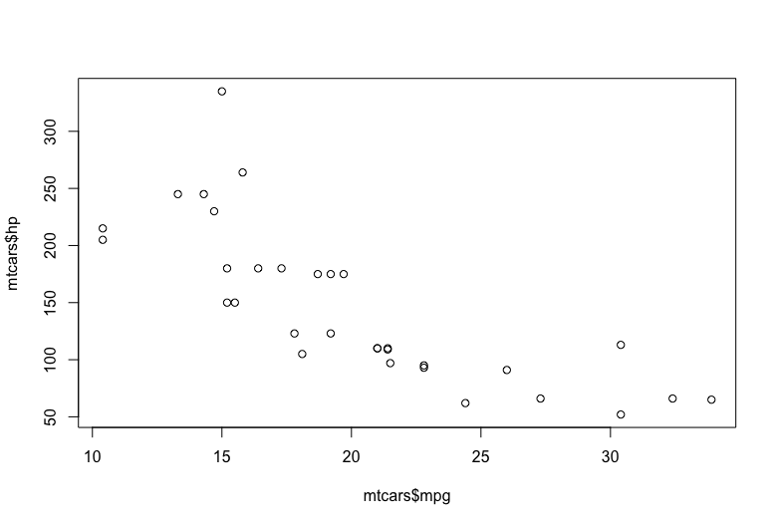

The second plot is with explaining labels and header on the plot so the viewer understands what he/she is looking at.

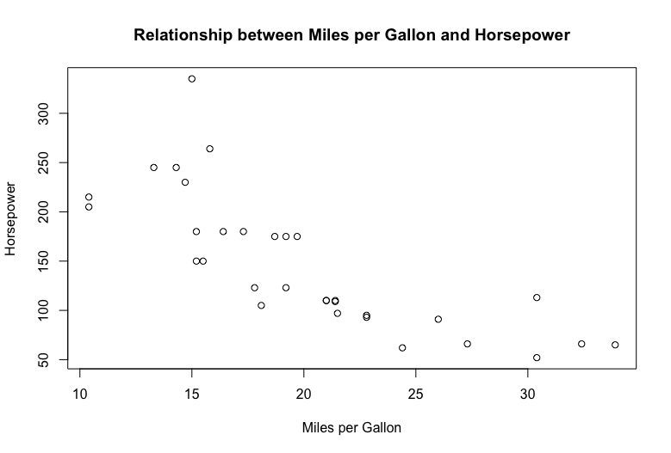

plot(mtcars$mpg,mtcars$hp, type = "h",

main = "Relationship between Miles per Gallon and Horsepower",

xlab = "Miles per Gallon",

ylab = "Horsepower")

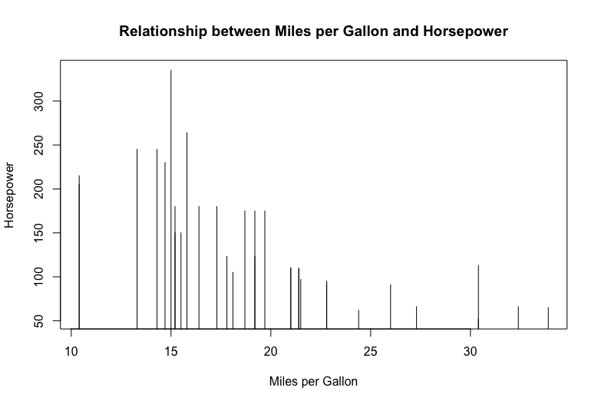

Code for the plots  
  
plot(mtcars$mpg,mtcars$hp)

plot(mtcars$mpg,mtcars$hp,

main = "Relationship between Miles per Gallon and Horsepower",

xlab = "Miles per Gallon",

ylab = "Horsepower")

plot(mtcars$mpg,mtcars$hp, type = "h",

main = "Relationship between Miles per Gallon and Horsepower",

xlab = "Miles per Gallon",

ylab = "Horsepower")

1. I have created a cash registry application where you can buy different breakfast products.En bild som visar text

   Automatiskt genererad beskrivning